# Appendix – Replication of main analysis using region FE

This appendix replicates the main analysis from the paper using region FE as alternative to year FE, exploited in the main research. Region FE shows an effect of GDP per capita on unarmed revolutions generalized to cross-sectional units. In other words, it shows how dynamic of GDP per capita affects probability of unarmed revolutions (within-effect). From Table 1 it is seen that in the models without multiple imputations (M2, M4), the coefficients are marginally significant, while in case of models estimated on imputed data, the results are highly significant. Thus, results are robust and endogeneity due to omitted time-invariant factors in the main analysis does not affect results substantially.

| Table 1. Logistic regression models for “rare events” on unarmed revolutions occurrence with region FE, 1950-2019 | | | | | | | | |
| --- | --- | --- | --- | --- | --- | --- | --- | --- |
|  | Dependent Variable: | | | | | | | |
| Variable | NAVCO 1.3 | | | | Beissinger's data | | | |
| M1 | M1 (imp) | M2 | M2  (imp) | M3 | M3  (imp) | M4 | M4  (imp) |
| (Intercept) | -2.55 | -6.79 | -10.59 | -18.66 | -5.18 | -7.14 | -14.7 | -20.44 |
|  | (-1.24) | (-3.64)*** | (-1.65)* | (-3.25)*** | (-2.89)** | (-4.81)*** | (-2.91)** | (-4.19)*** |
| GDP pc, ln | -0.33 | -0.08 | 1.54 | 2.68 | -0.19 | 0.03 | 2.05 | 3.13 |
|  | (-1.4) | (-0.39) | (1.07) | (2.13)* | (-0.98) | (0.16) | (1.78)* | (2.9)** |
| GDP pc, ln (sq) |  |  | -0.11 | -0.16 |  |  | -0.13 | -0.18 |
|  |  |  | (-1.32) | (-2.26)* |  |  | (-1.96)* | (-2.92)** |
| Population, ln | 0.05 | 0.15 | 0.05 | 0.15 | 0.24 | 0.29 | 0.24 | 0.28 |
|  | (0.64) | (2.32)* | (0.62) | (2.31)* | (4.17)*** | (4.99)*** | (4.28)*** | (5.13)*** |
| Polity | <0.001 | 0.01 | <0.001 | 0.01 | -0.02 | -0.02 | -0.02 | -0.02 |
|  | (0.04) | (0.4) | (-0.03) | (0.29) | (-1.07) | (-1.34) | (-1.07) | (-1.39) |
| Polity (sq) | -0.01 | -0.01 | -0.01 | -0.01 | -0.01 | -0.01 | -0.01 | -0.01 |
|  | (-2.35)** | (-2.6)** | (-2.32)* | (-2.5)** | (-3.26)*** | (-4.23)*** | (-3.23)*** | (-4.08)*** |
| Regime durability, ln | -0.07 | -0.04 | -0.07 | -0.04 | -0.06 | -0.04 | -0.06 | -0.04 |
|  | (-0.6) | (-0.44) | (-0.58) | (-0.43) | (-0.73) | (-0.58) | (-0.73) | (-0.58) |
| Urbanization | 0.01 | <0.001 | 0.01 | <0.001 | <0.001 | <0.001 | <0.001 | <0.001 |
|  | (0.64) | (0.59) | (0.71) | (0.73) | (-0.58) | (-0.75) | (-0.47) | (-0.62) |
| Corruption | 1.47 | 1.57 | 1.42 | 1.51 | 1.03 | 0.95 | 0.96 | 0.88 |
|  | (2.95)** | (3.56)*** | (2.85)** | (3.46)*** | (3.05)** | (3.17)*** | (2.84)** | (2.97)** |
| Education | 0.1 | 0.11 | 0.09 | 0.1 | 0.11 | 0.09 | 0.11 | 0.08 |
|  | (1.79)* | (2.36)** | (1.69)* | (2.22)* | (2.47)** | (2.24)* | (2.36)** | (2.16)* |
| Oil rent pc | -0.03 | -0.05 | -0.03 | -0.05 | -0.01 | -0.02 | -0.01 | -0.02 |
|  | (-1.32) | (-2.36)** | (-1.41) | (-2.47)** | (-0.57) | (-1.24) | (-0.66) | (-1.35) |
| Rev. in region (t) | 1.43 | 1.31 | 1.44 | 1.33 | 0.65 | 0.73 | 0.67 | 0.74 |
|  | (6.95)*** | (7.25)*** | (7)*** | (7.37)*** | (3.78)*** | (5.08)*** | (3.86)*** | (5.18)*** |
| Rev. in region (t-1) | 0.54 | 0.5 | 0.54 | 0.51 | 0.49 | 0.57 | 0.5 | 0.58 |
|  | (2.87)** | (2.96)** | (2.89)** | (3.01)** | (3.01)** | (3.92)*** | (3.07)** | (3.94)*** |
| Rev. in the past | 0.28 | 0.32 | 0.27 | 0.3 | 0.12 | 0.17 | 0.12 | 0.16 |
|  | (2.82)** | (4.07)*** | (2.64)** | (3.81)*** | (2.39)** | (3.87)*** | (2.08)* | (3.35)*** |
| Economic growth, 5-year average | 0.42 | 1.06 | 0.01 | 0.42 | -1.23 | -0.16 | -1.68 | -0.96 |
|  | (0.23) | (0.73) | (<0.001) | (0.29) | (-0.59) | (-0.1) | (-0.81) | (-0.62) |
| N | 6202 | 9 667 | 6202 | 9 667 | 6202 | 9 667 | 6202 | 9 667 |
| Note: ***p<0.001, **p<0.01, *p<0.05; all predictors are at t-1 except revolution in the region and revolutions in the past; z-statistics are in parenthesis; region fixed effects are included in all models; standard errors are clustered on countries; models with multiple imputations (imp) are based on 50 imputed models. | | | | | | | | |

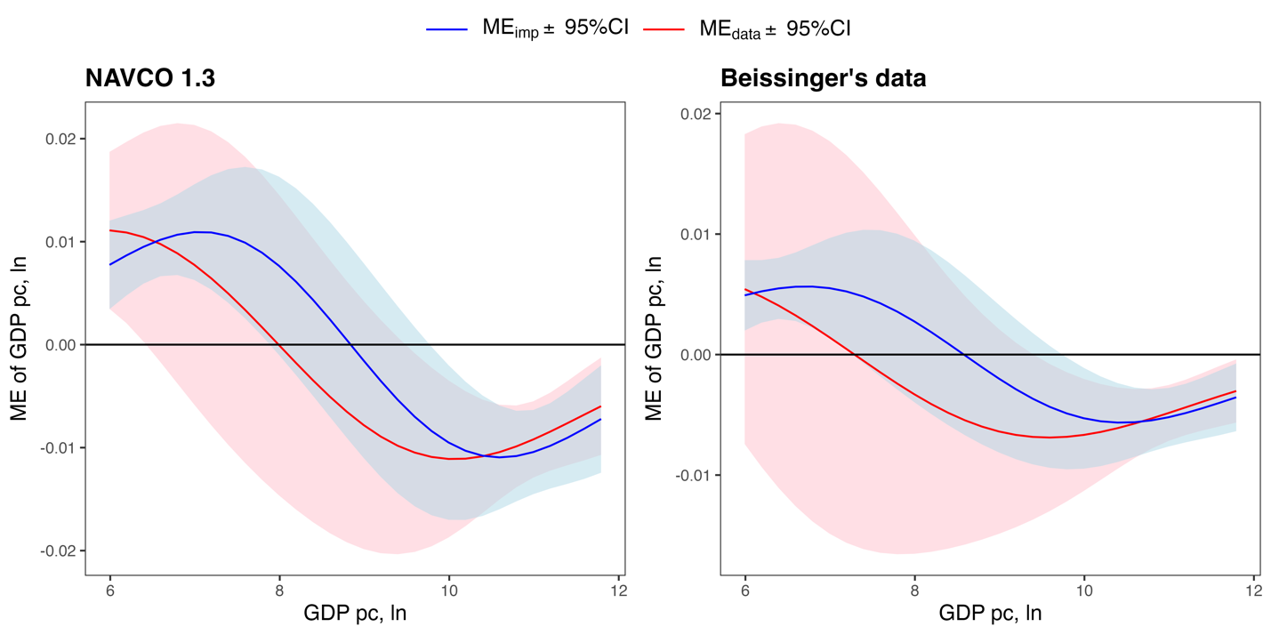

Figure 1. Marginal effect of GDP per capita conditional on its values. Note: red line shows models estimated on original sample with listwise deletion from Table 1, blue line shows models estimated on 50 imputed datasets; 95% CI is plotted.

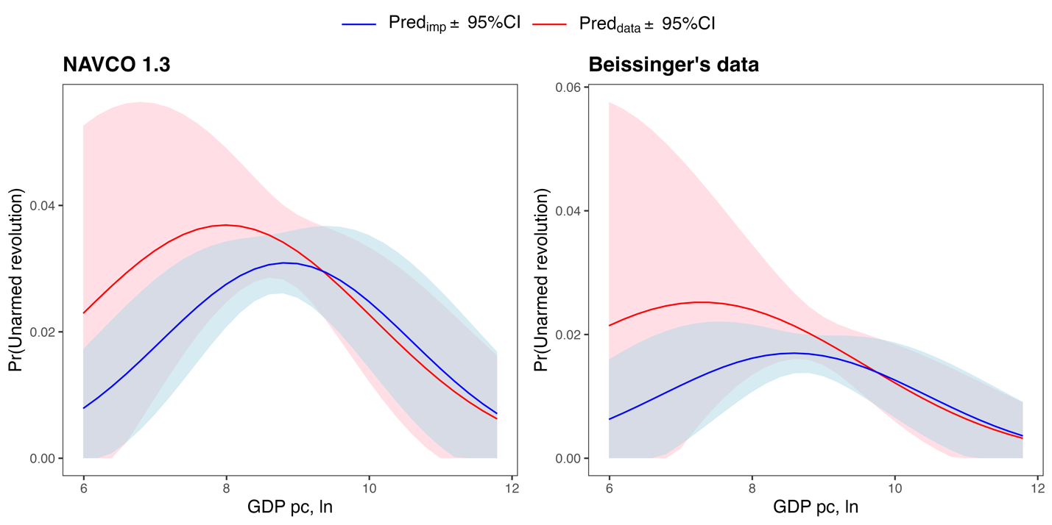

Figure 2. Adjusted predictions of probability of unarmed conditional on GDP per capita. Note: red line shows models estimated on original sample with listwise deletion from Table 1, blue line shows models estimated on 50 imputed datasets; 95% CI is plotted.